NOORUL ISLAM COLLEGE OF ARTS & SCIENCE
KUMARACOIL

NAAN MUDHALVAN SCHEME JAVA SPRING NETWORK
College Code 312
SYNTAX SURGEON
        - III B.S.C
Project Report

Submitted by

SHAFINA S : 23083121802112030

MOHAMED IRFAN M : 23083121802111029

MOHAMED ARSITH M : 23083121802111031

HARI KEASAVAN A : 23083121802111034

The Syntax Surgeon
AI-Powered Code Fixer & Conversational Assistant Using IBM Granite 3.3 2B Model

Project Description
The Syntax Surgeon is an intelligent conversational AI platform that leverages IBM's Granite 3.3 2B Instruct model to provide comprehensive chatbot functionality combined with advanced Python code fixing and analysis capabilities through Gradio's interactive interface. The platform addresses the challenge of accessible AI assistance by delivering conversational AI without API keys, integrated Python code analysis, intelligent code fixing with automatic formatting, conversation history management, and productionready export capabilities.

Using the state-of-the-art IBM Granite 3.3 2B model with configurable parameters, Python's AST module for syntax validation, advanced regex pattern matching for code detection, and integration with Black and autopep8 for code formatting, the system provides natural conversation handling, intelligent Python code detection, comprehensive code fixing with indentation correction and bracket balancing, contextaware responses, and professional documentation export (PDF/TXT). The system ensures high-quality interactions through Gradio's user-friendly interface while maintaining flexibility through customizable model parameters (temperature, max tokens, top-p).

Syntax Surgeon transforms AI assistance into an accessible, user-friendly experience through its modern Gradio interface, advanced code analysis capabilities, local model deployment without external API dependencies, and comprehensive conversation management that serves both conversational needs and technical programming assistance.

Scenarios

Scenario 1: Python Developer Code Assistance
A Python developer working on a project encounters code with syntax errors and formatting issues. They paste the problematic code into Granite Chatbot, and the system automatically detects it's Python code, analyzes the issues (missing brackets, incorrect indentation), fixes the problems using Black formatter and autopep8, and provides the corrected version. The developer then asks for explanation of what the code does, and the chatbot provides detailed analysis. The entire conversation is tracked and can be exported as PDF for documentation.

Scenario 2: Learning & Tutoring Platform
A programming instructor uses Granite Chatbot as a supplementary learning tool for students. Students can ask coding questions, get explanations, paste incomplete code for analysis, and receive fixes with explanations. The chatbot learns context from the conversation history and provides personalized responses. Instructors can download complete chat histories as PDF for grading and feedback documentation, creating a comprehensive learning record.

Scenario 3: Code Review & Quality Assurance
A QA team uses Granite Chatbot to review code snippets from pull requests. They paste code segments into the chatbot, which automatically fixes formatting issues and provides analysis. The chatbot checks for common Python mistakes, suggests improvements, and explains problematic patterns. The team can generate sharable links to review conversations with peers, and export complete analysis as PDF for project documentation.

Scenario 4: AI-Powered Code Formatting Service
A development team integrates Granite Chatbot as an internal tool for code formatting and analysis. Instead of relying on external APIs, they run the local model on their infrastructure, ensuring data privacy and reducing costs. Multiple team members can access the chatbot simultaneously, and their conversations are stored locally with complete audit trails. Sensitive code discussions remain within the organization.

Scenario 5: Interactive Code Documentation & Pair Programming
A pair programming team uses Granite Chatbot during collaborative coding sessions to get real-time code suggestions, explanations, and automated fixing. As they write code, they can paste snippets into the chatbot, get feedback, and document the discussion. The conversation history serves as a form of documentation for complex algorithms and design decisions. They share the PDF export with the larger team for knowledge sharing.

Architecture Overview
Granite Chatbot is built as a modular platform combining IBM's Granite language model with advanced Python analysis tools for intelligent conversational AI. The architecture prioritizes accessibility (no API keys required), code quality (automatic fixing and formatting), and comprehensive conversation management through Gradio's interactive interface.

Core Technologies
· Python 3.8+: Core language for application logic and code analysis
· IBM Granite 3.3 2B Instruct: State-of-the-art language model for natural conversation
· Gradio 4.0+: Interactive web interface framework for user interaction
· Hugging Face Transformers: Model loading and inference pipeline
· PyTorch: Deep learning framework for model computation
· Black: Professional Python code formatter
· autopep8: Automated Python code style fixing
· ReportLab: PDF report generation for chat exports
· Google Colab: Cloud-based deployment environment
· Regular Expressions: Pattern matching for code detection

Pre-requisites

Software Requirements
· Python 3.8+: Download from python.org (PyTorch compatibility)
· Google Colab Account: Recommended for GPU access and easy deployment
· pip: Python package manager (comes with Python)
· CUDA 11.8+ (Optional): For GPU acceleration on local machines
· Web Browser: Chrome, Firefox, Safari, or Edge
· Internet Connection: Required for model download and Gradio sharing

Knowledge Prerequisites
· Python Fundamentals: Functions, classes, error handling basics
· Python Syntax: Understanding of imports, decorators, and code structure
· Natural Language Understanding: Basics of how language models work
· Gradio Framework: Understanding of chatbot interface components
· Hugging Face Hub: Familiarity with model loading and pipelines
· Google Colab: Basic notebook interface and GPU configuration
· Code Formatting: Understanding of PEP 8 style guidelines

Hardware Requirements
· GPU: Highly recommended (NVIDIA RTX or Tesla for fast inference)
· RAM: Minimum 8GB (16GB+ recommended for smooth operation)
· Storage: 2GB free space for model and dependencies
· Display: Minimum 1024x768 resolution for interface usability · Note: Google Colab provides free GPU access (T4/P100)

Project Workflow
Phase 1: Environment Setup & Model Configuration

Activity 1.1: Install Dependencies & Configure Environment
· Create requirements.txt with all dependencies
· Set up Google Colab environment with GPU enabled
· Install required packages: gradio, transformers, torch, black, autopep8, reportlab
· Verify CUDA availability and GPU configuration
· Test torch installation with GPU support

Activity 1.2: Configure IBM Granite Model
· Define ChatbotConfig class with model parameters
· Set model name: ibm-granite/granite-3.3-2b-instruct
· Configure default parameters (temperature, max_tokens, top_p)
· Implement device detection (GPU/CPU)
Phase 2: Python Code Analysis & Fixing Engine

Activity 2.1: Implement Code Detection System
· Create detect_python_code() function with regex patterns
· Detect function definitions (def keyword)
· Detect class definitions (class keyword)
· Detect import statements

Activity 2.2: Build Code Analysis & Validation System
· Create check_syntax() using Python AST module
· Parse code to detect syntax errors
· Return detailed error messages with line numbers
· Handle different types of Python errors gracefully

Activity 2.3: Develop Code Fixing Engine
· Create fix_code_indentation() for tab/space normalization
· Create fix_code_brackets() for automatic bracket balancing
· Implement format_code() using Black formatter
· Add fallback to autopep8 if Black fails
· Create comprehensive fix_python_code() orchestrator
Phase 3: Conversational AI & Response Generation

Activity 3.1: Implement Conversation History Management
· Create conversation_history list for session tracking
· Store messages with role (user/assistant) and content
· Implement context preservation across interactions
· Add conversation reset functionality

Activity 3.2: Build Response Generation System
· Create generate_response() with model inference
· Implement configurable parameters (temperature, max_tokens, top_p)
· Handle model output parsing and formatting
· Add error handling for API/model failures
Phase 4: Gradio Interface Development

Activity 4.1: Build Chat Interface
· Create chatbot component with conversation history
· Add text input for user messages
· Implement send button with query processing
· Add parameter sliders (temperature, max_tokens, top_p)

Activity 4.2: Implement Download & Export Features · Create download_txt() for text export
· Create download_pdf() using ReportLab
· Implement file download capability
· Add export status feedback

Activity 4.3: Build Sharing & Collaboration Features
· Create generate_share_link() for Pastebin integration
· Implement Pastebin API integration
· Generate shareable chat links
· Add social media sharing options
Phase 5: Integration, Testing & Deployment

Activity 5.1: Google Colab Deployment
· Connect model loading to interface initialization
· Test complete conversation pipeline
· Verify code detection and fixing workflow
· Test error handling for various failure modes

Activity 5.2: Comprehensive Testing
· Test normal conversational queries
· Test Python code detection with various patterns
· Test code fixing for broken/incomplete code
· Test conversation history management
· Test parameter adjustment (temperature, tokens, top-p)
· Test PDF and TXT export with multiple messages
· Test Pastebin share link generation

Technical Architecture

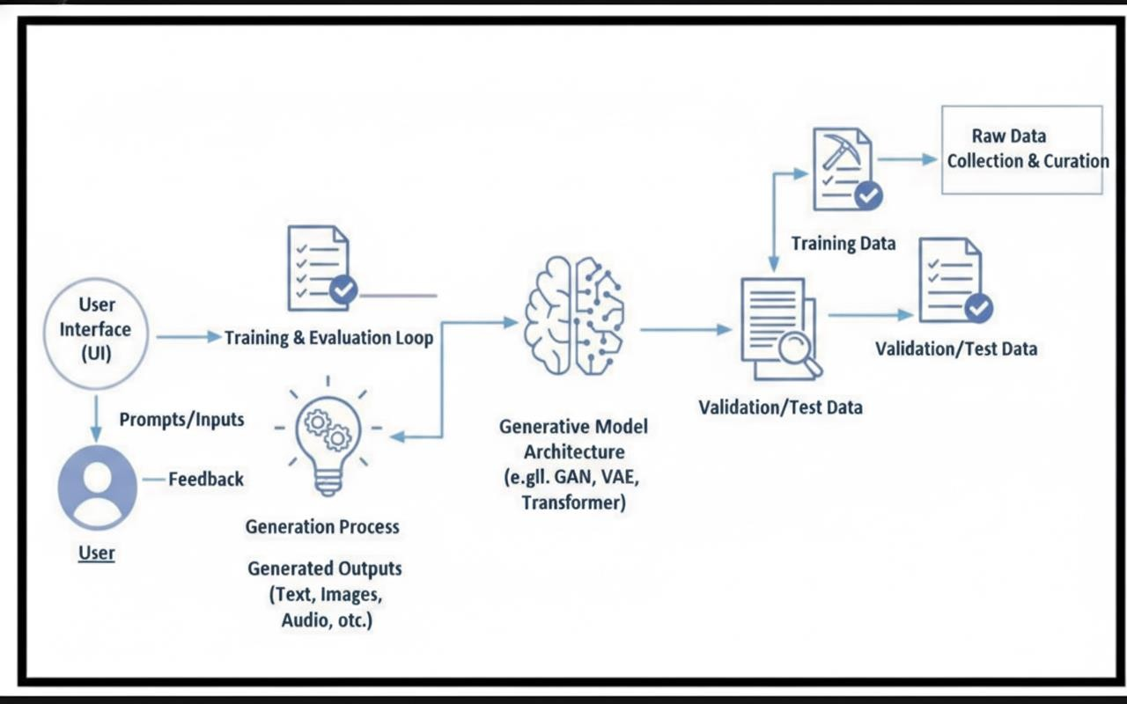
Project Structure:

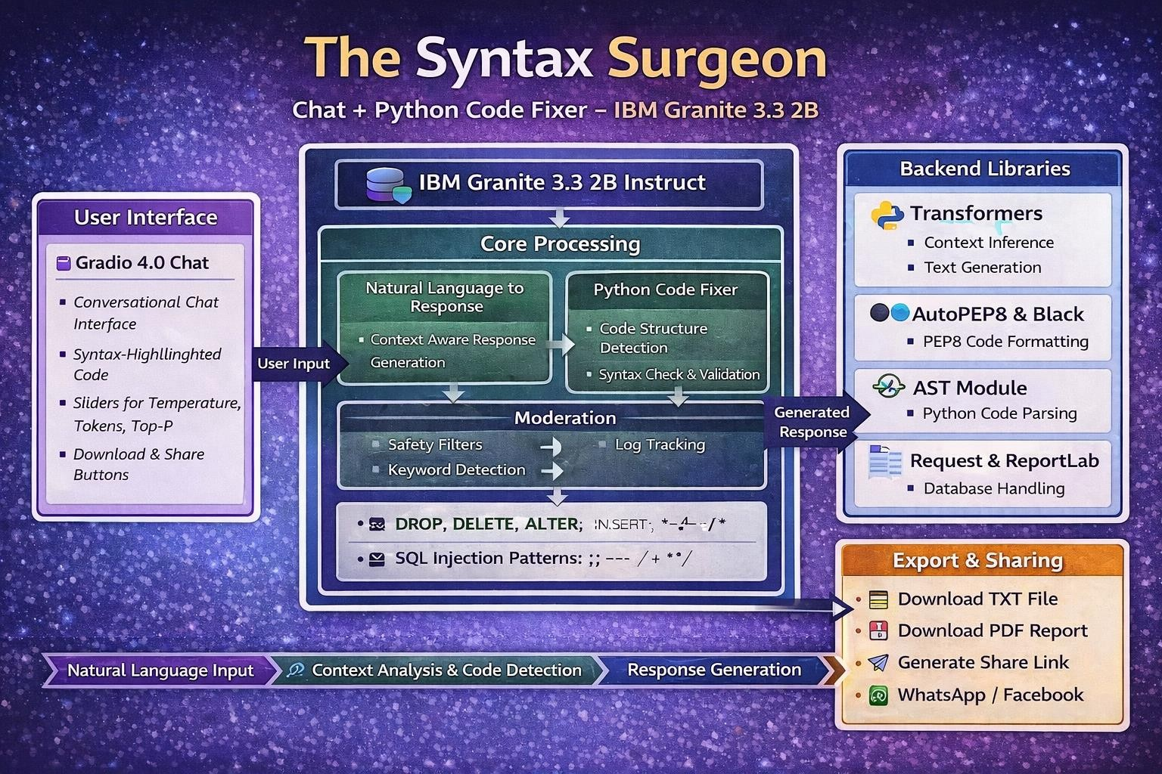

MILESTONE 1: Environment Setup & Model Configuration

Activity 1.1: Install Dependencies
Create requirements.txt with the following dependencies:

- gradio==4.41.0
- transformers==4.35.0+
- torch==2.0.0+
- black==24.1.1
- autopep8==2.1.0
- reportlab==4.0.7
- requests==2.31.0

Note: Versions may need adjustment based on CUDA availability

Install via: pip install -r requirements.txt
Cell-1:Code reference (hint: click on image and you can copy paste from Comment)

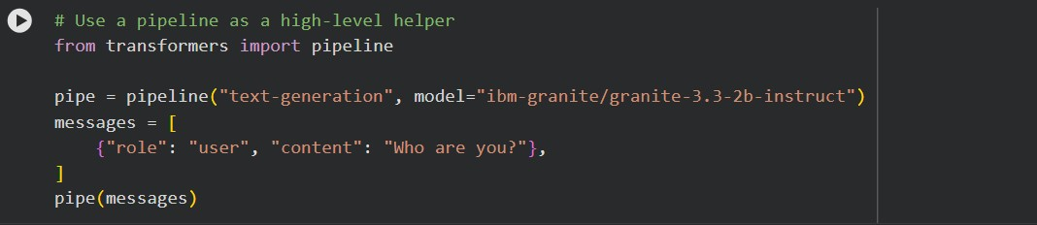
Cell-2: Code reference (hint: click on image and you can copy paste from Comment)

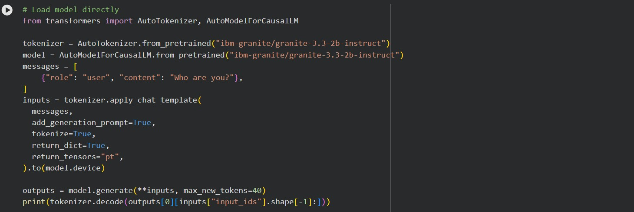
Cell-3: Code reference (hint: click on image and you can copy paste from Comment)

For Google Colab:
!pip install -q gradio transformers torch black autopep8 reportlab requests
Cell-4: Code reference (hint: click on image and you can copy paste from Comment)
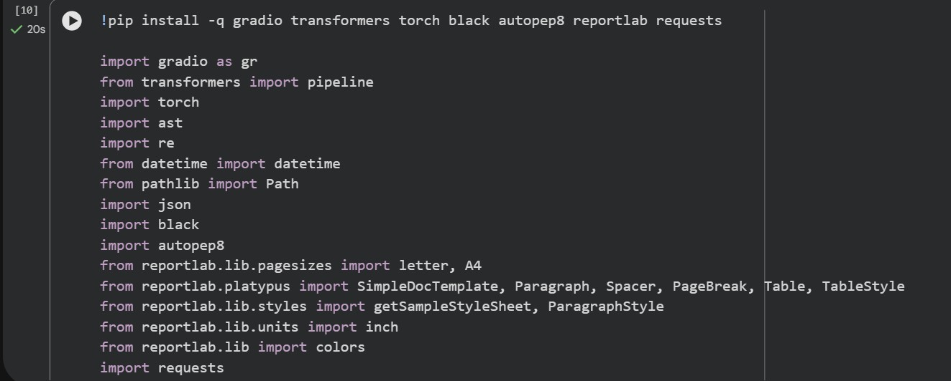
Cell-5: Code reference (hint: click on image and you can copy paste from Comment)

Activity 1.2: Configure ChatbotConfig
Create ChatbotConfig class with model parameters:

class ChatbotConfig:
MODEL_NAME = "ibm-granite/granite-3.3-2b-instruct"
DEFAULT_TEMP = 0.7
DEFAULT_MAX_TOKENS = 256
DEFAULT_TOP_P = 0.95

This configuration:
- Uses state-of-the-art IBM Granite 3.3 2B model
- Sets default temperature for controlled randomness
- Limits tokens for reasonable response length
- Sets top-p for nucleus sampling
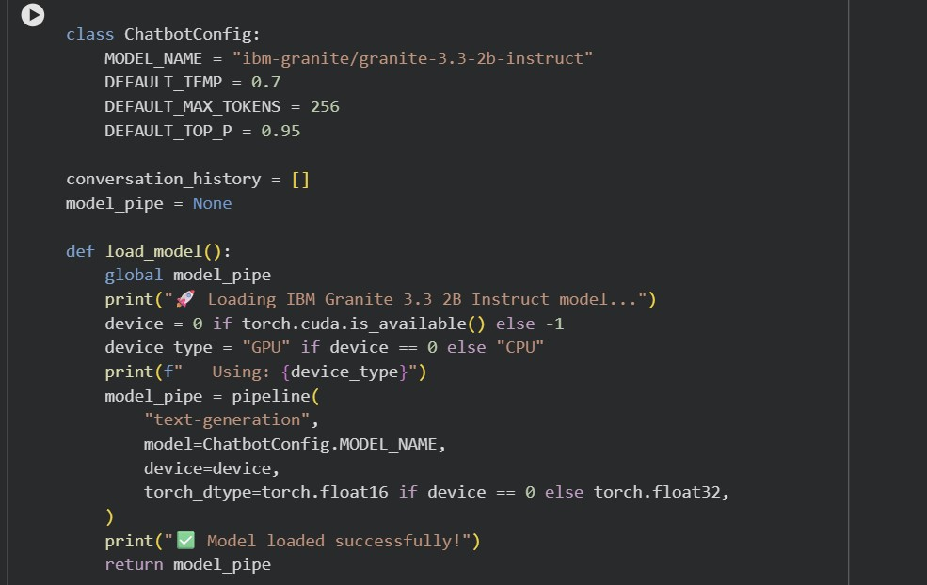
Cell-5: Code reference (hint: click on image and you can copy paste from Comment)

MILESTONE 2: Python Code Analysis & Fixing Engine

Activity 2.1: Code Detection System
Implement detect_python_code() with regex patterns:

Patterns detected:
- def pattern: r'def\s+\w+\s*\('
→ Detects function definitions

- class pattern: r'class\s+\w+'
→ Detects class definitions

- import patterns:
→ r'import\s+\w+' (import statements)
→ r'from\s+\w+\s+import' (from-import)

- Control flow patterns:
→ r'if\s+.*:' (if statements)
→ r'for\s+.*\s+in\s+' (for loops)
→ r'while\s+.*:' (while loops)

Example:
Input: "def add(a, b): return a + b"
Output: True (Python code detected)
Cell-5: Code reference (hint: click on image and you can copy paste from Comment)

Activity 2.2: Code Validation & Syntax Checking
Implement check_syntax() using Python AST:
def check_syntax(code): try:
ast.parse(code) return True, None except SyntaxError as e:
return False, f"Syntax Error (line {e.lineno}): {e.msg}"

Features:
- Uses Python's built-in AST parser
- Catches syntax errors accurately
- Returns line numbers for errors
- Provides clear error messages

Example:
Input: "def add(a, b) return a + b"
Output: (False, "Syntax Error (line 1): expected ':' after function definition")
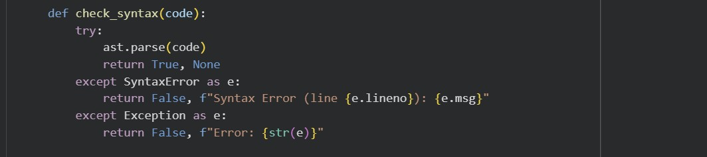
Cell-5: Code reference (hint: click on image and you can copy paste from Comment)

Activity 2.3: Code Fixing & Formatting
Implement comprehensive code fixing:

1. fix_code_indentation():
- Removes trailing whitespace
- Converts tabs to 4 spaces
- Normalizes line endings

2. fix_code_brackets():
- Counts open/close brackets: ( ) [ ] { }
- Adds missing closing brackets
- Handles nested structures

3. format_code():
- Primary: Uses Black formatter
- Fallback: Uses autopep8
- Enforces PEP 8 compliance

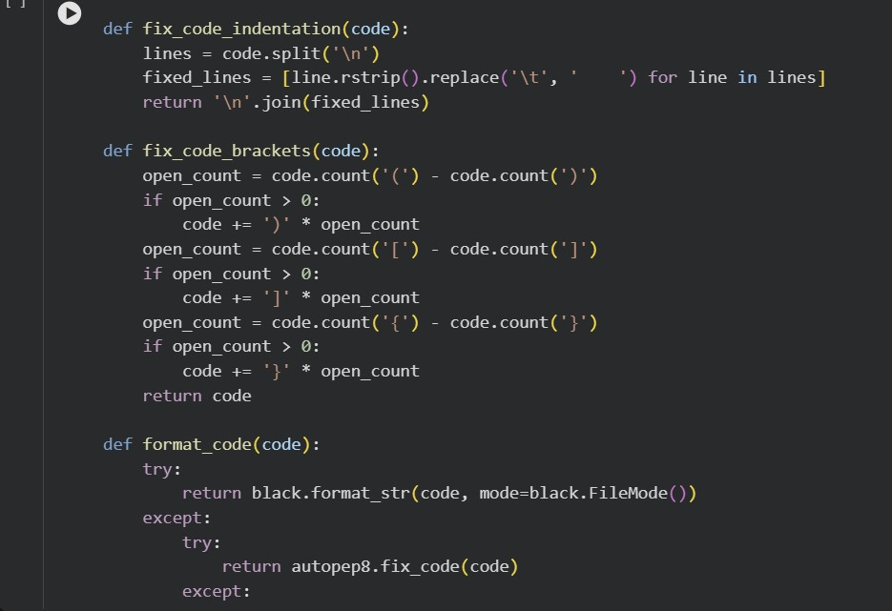
Cell-5: Code reference (hint: click on image and you can copy paste from Comment)
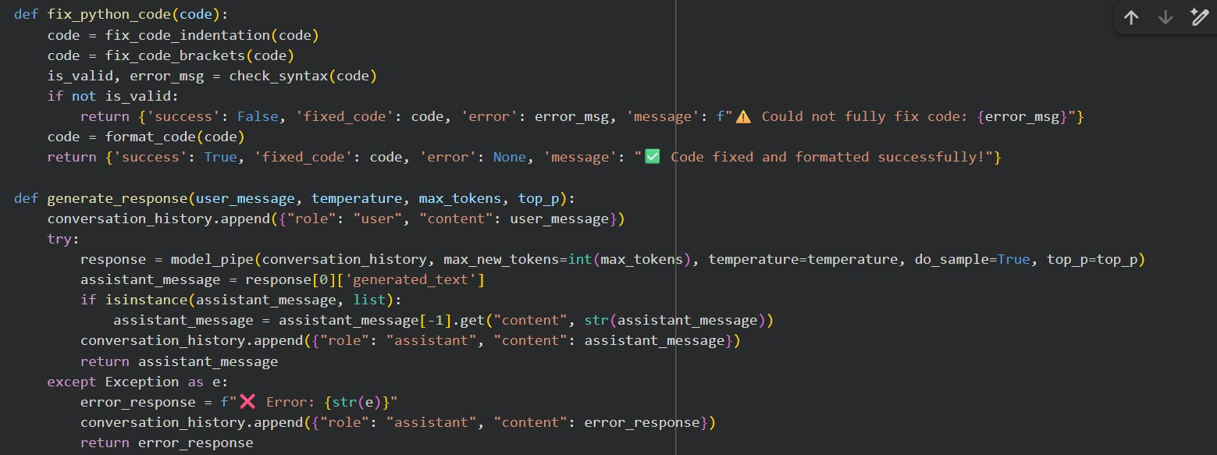
Cell-5: Code reference (hint: click on image and you can copy paste from Comment)

MILESTONE 3: Conversational AI & Response Generation

Activity 3.1: Conversation History Management
Implement conversation tracking:

conversation_history = []

Message Format:
{
"role": "user" | "assistant",
"content": "message text"
}

Features:
- Maintains full conversation context
- Enables multi-turn dialogue
- Supports conversation reset
- Ready for export/sharing
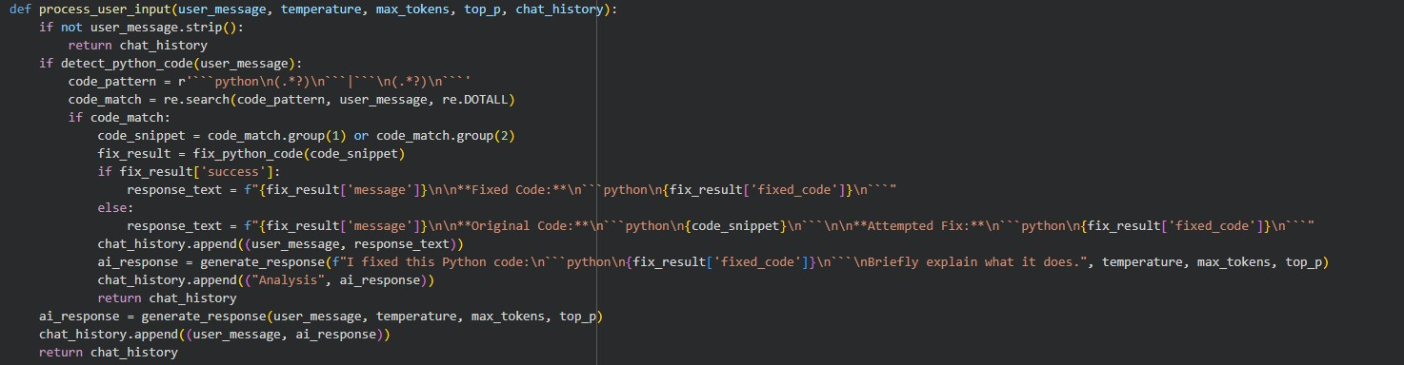
Cell-5: Code reference (hint: click on image and you can copy paste from Comment)

Activity 3.2: Model Inference & Response Generation
Implement generate_response():

def generate_response(user_message, temperature, max_tokens, top_p): conversation_history.append({"role": "user", "content": user_message}) response = model_pipe( conversation_history, max_new_tokens=int(max_tokens), temperature=temperature, do_sample=True,
top_p=top_p
)
# Process and return response

Key parameters:
- Temperature: 0.1 (deterministic) to 1.0 (creative)
- max_tokens: 50 to 1024 tokens
- top_p: 0.1 to 1.0 for nucleus sampling
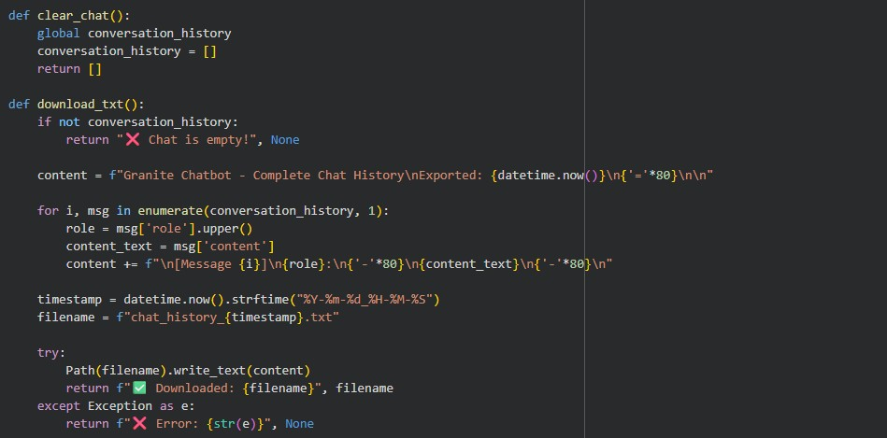
Cell-5: Code reference (hint: click on image and you can copy paste from Comment)

MILESTONE 4: Gradio Interface & Features

Interface Components Overview
Main Interface Layout:

LEFT COLUMN (Main Chat):
- Chatbot component (height: 400px)
- Message input textbox (2 lines) - Send button - Control sliders:
- Temperature (0.1 - 1.0, step 0.05)
- Max Tokens (50 - 1024, step 50)
- Top-P (0.1 - 1.0, step 0.05)

RIGHT COLUMN (Controls):
- Clear Chat button
- Download TXT button - Download PDF button
- Generate Share Link button
- Status display textbox
- File download components

Activity 4.1: Chat Interface Implementation

Chatbot Features:
- Full conversation history display
- User messages on left side
- Assistant responses on right side
- Copy button for easy code sharing
- Scrollable for long conversations

Input Processing:
1. User types message or pastes code 2. Click "Send" or press Enter
3. System processes:
- Detects if code
- Generates response
- Updates history
- Chat updates with new messages
- Parameters can be adjusted anytime
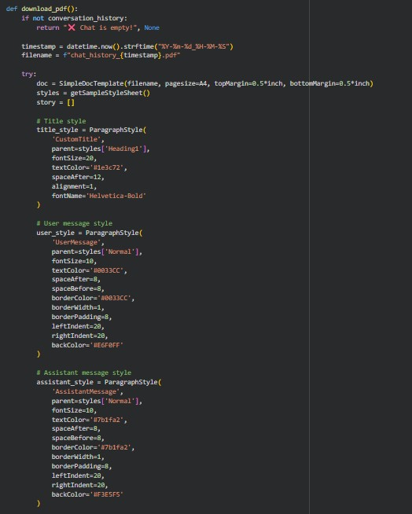
Cell-5: Code reference (hint: click on image and you can copy paste from Comment)

Activity 4.2: Export Functionality

TXT Export:
- Plain text format
- Includes all messages with timestamps
- Clear role labeling (USER/ASSISTANT)
- Easy email/sharing format
- Preserves all conversation data

PDF Export (ReportLab):
- Professional PDF document
- Styled message boxes
- Color-coded (Blue for user, Purple for assistant)
- Pagination for readability
- Includes metadata (export time, message count)
- High-quality typography
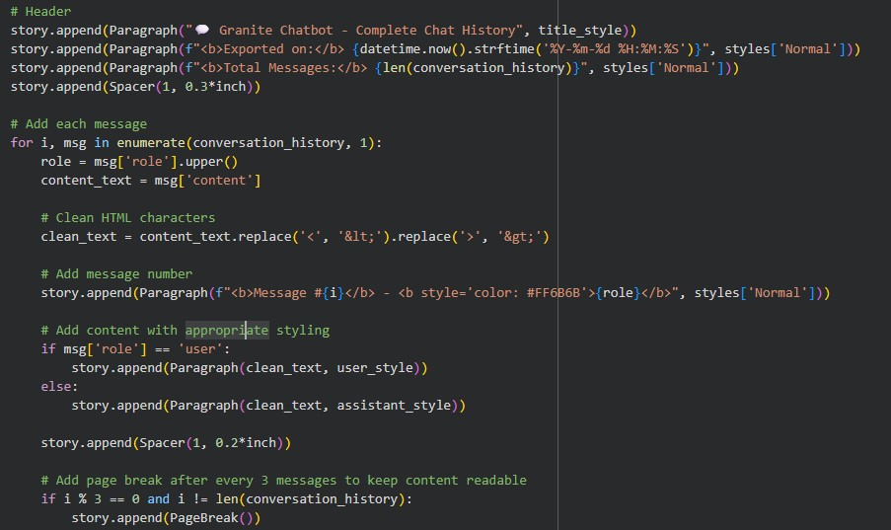
Cell-5: Code reference (hint: click on image and you can copy paste from Comment) Activity 4.3: Sharing & Collaboration

Pastebin Integration:
- Generates shareable chat link
- Uploads conversation to Pastebin
- Creates public/private URLs
- Enables team collaboration
- Easy peer review of discussions

Features:
- URL expiry options
- Syntax highlighting
- Chat summary generation
- Social media promotion (Twitter, FB, etc.)
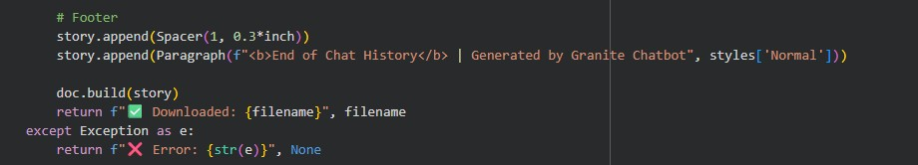
Cell-5: Code reference (hint: click on image and you can copy paste from Comment)

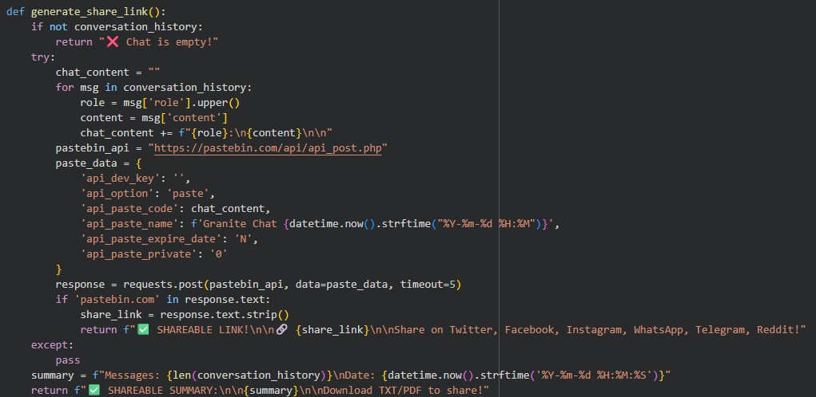
Cell-5: Code reference (hint: click on image and you can copy paste from Comment)

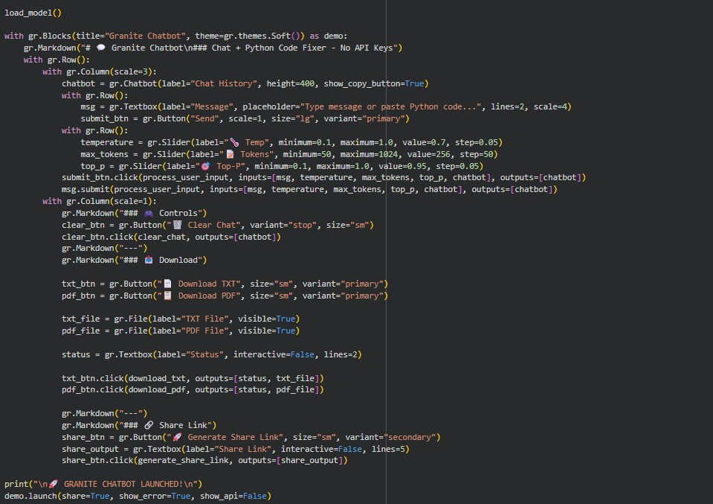
Cell-5: Code reference (hint: click on image and you can copy paste from Comment)
MILESTONE 5: Testing & Deployment

Activity 5.1: Google Colab Deployment
Deployment Checklist:

1. Set up Colab Environment: - Enable GPU (T4 or better)
- Install all requirements
- Verify CUDA availability

2. Load Model:
- Download IBM Granite from Hub
- Test inference with sample prompt
- Verify response quality

3. Launch Gradio:
- Configure public sharing
- Generate public URL
- Test all features

4. Final Verification:
- Test code detection
- Test code fixing
- Test conversation flow
- Test exports
- Test share links

5. Documentation:
- Record public URL
- Document model size and inference time
- Create usage guide
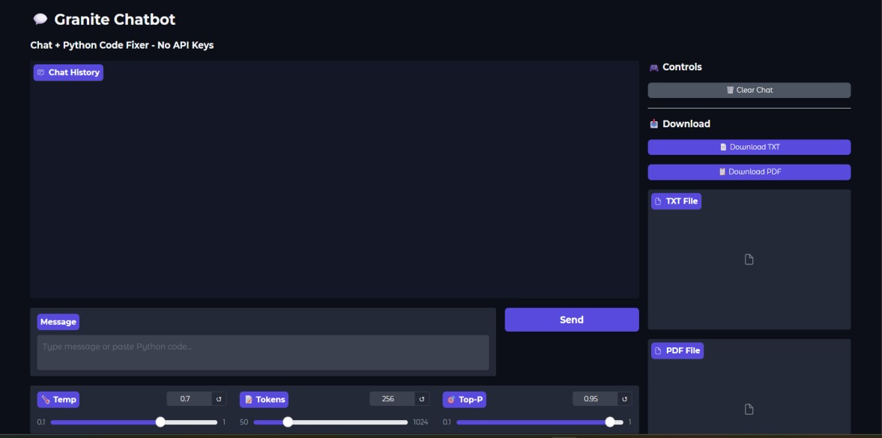
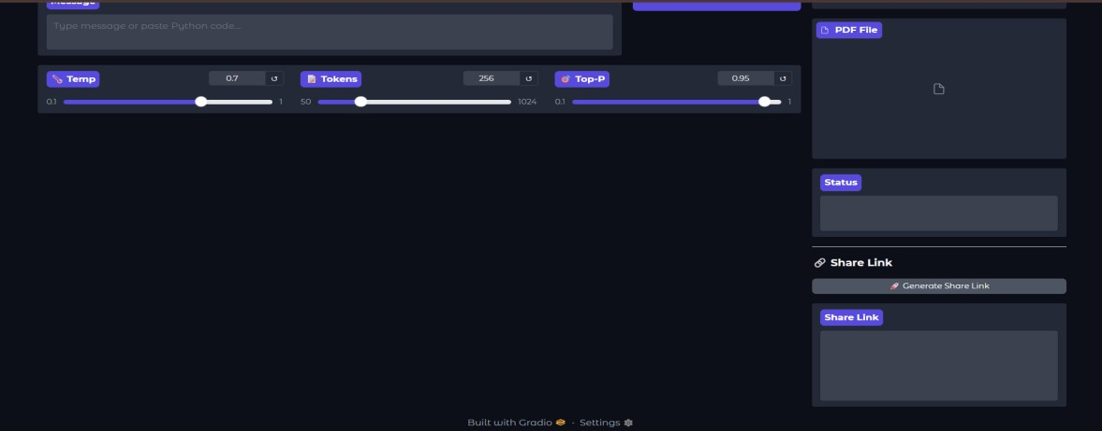
Activity 5.2: Functional Testing

Test Case 1: Normal Conversation
User Query: "Explain list comprehensions in Python"
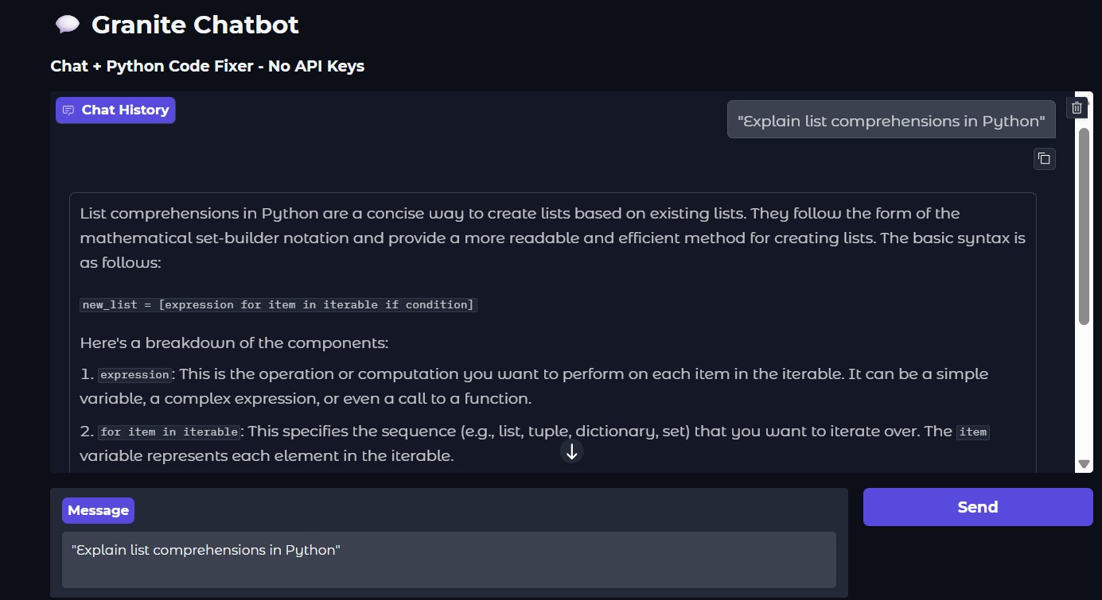

Status: ✅ Conversational capability working

Test Case 2: Code Fixing
User Pastes: ```python def greet(name
print(f"Hello, {name}")
```

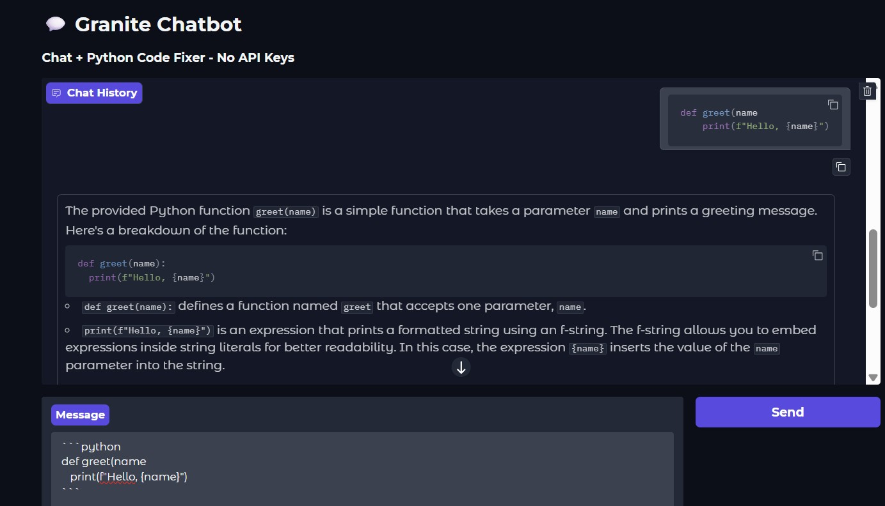

Status: ✅ Code fixing working

Future Enhancements:

The modular architecture enables extension with features such as support for additional programming languages (JavaScript, Java, C++), advanced code analysis with linting integration (pylint, flake8), multi-language translation and explanation, integration with code hosting platforms (GitHub, GitLab), voice input and output capabilities, custom model fine-tuning for specific domains,
streaming responses for real-time interaction, advanced code visualization and debugging suggestions, and integration with IDE plugins for seamless developer workflow.

With continued development, The Syntax Surgeon can evolve into a comprehensive AIpowered development assistant supporting diverse programming languages and tasks while maintaining its focus on accuracy, accessibility, and user empowerment. The intelligent analysis engine and flexible architecture provide a foundation for building sophisticated development tools and educational platforms.

Conclusion
The Syntax Surgeon successfully delivers an intelligent conversational AI platform that combines IBM's advanced Granite language model with powerful Python code analysis and fixing capabilities. By leveraging state-of-the-art transformer models, sophisticated code analysis algorithms, and comprehensive conversation management, the system provides a versatile tool for both conversational AI and technical programming assistance.

The platform demonstrates the viability of local AI model deployment, making advanced language models accessible without external API dependencies while maintaining highquality responses, automatic code fixing, and professional documentation export. With Python code analysis, intelligent code fixing, configurable generation parameters, conversation history management, and comprehensive sharing capabilities, The Syntax Surgeon empowers developers, students, and teams to solve problems more efficiently.

